- The sys.sp_change_user_login is used to change login of the user. Also it checks permissions. Checks if the given user name is right and if this possible to change login.
First ROLLBACK happens when it can’t match login name. So it’s evert the changes made within a transaction and restore the data to its state before the transaction began.

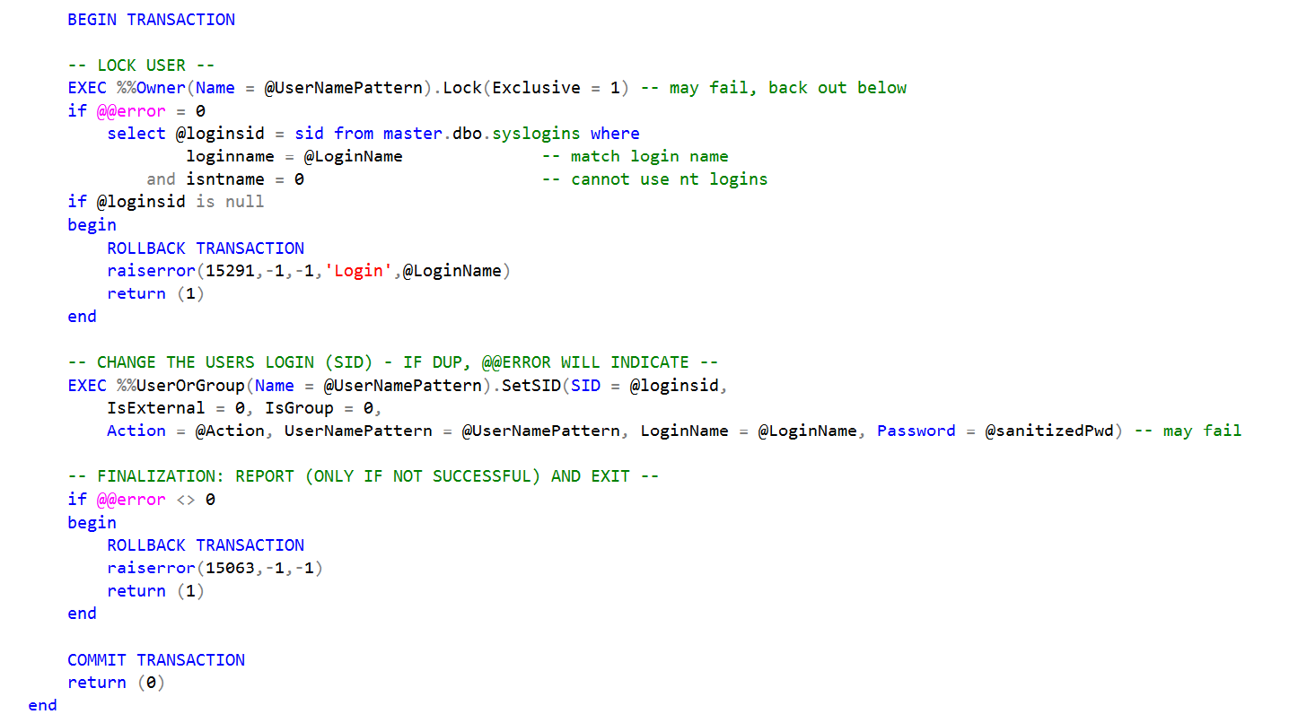
COMMIT happens when there is no error, and the user login can be changed.

- There would be code with commends what I did in the Procedure.
USE AdventureWorks2022
GO

CREATE PROCEDURE ChangePassword
@personID INT,
@newPassword NVARCHAR(50)
AS
BEGIN
SET NOCOUNT ON;
DECLARE @error INT;

BEGIN TRANSACTION;

-- Check if the person exists

IF EXISTS (SELECT * FROM Person.Person WHERE BusinessEntityID = @personID)
BEGIN
-- Update the password in the Password table

UPDATE Person.Password
SET PasswordHash = @newPassword
WHERE BusinessEntityID = @personID;

-- Attempt to insert a record with an invalid ID

INSERT INTO dbo.DatabaseLog VALUES (@personID, 'SomeValue');

-- Check for errors
SET @error = @@ERROR;
IF @error <> 0
BEGIN
-- Rollback if an error occurred

ROLLBACK TRANSACTION;
RETURN @error;
END
END
ELSE
BEGIN
-- Rollback if person doesn't exist

ROLLBACK TRANSACTION;
-- You can define your own error codes here

RETURN 1;
END
-- Commit the transaction if everything goes well
COMMIT TRANSACTION;
END

- Here trigger, that will be executed after any changes in the table ProductCostHistory
CREATE TRIGGER trg_ProductCostHistoryChanges
ON Production.ProductCostHistory
AFTER INSERT, UPDATE, DELETE
AS
BEGIN
SET NOCOUNT ON;

EXEC AnalyzeProductPriceChanges;
END;

